**PRINCIPAL RULES OF WRITING BUSINESS LETTERS**

**Ex. 1 Look at these letters. What differences in their layout can you observe?**

**Letter 1**

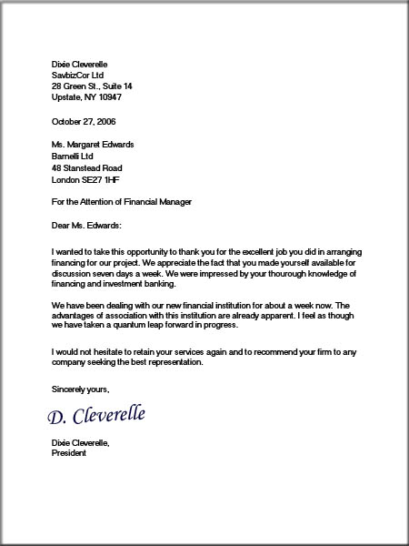

**Letter 2**

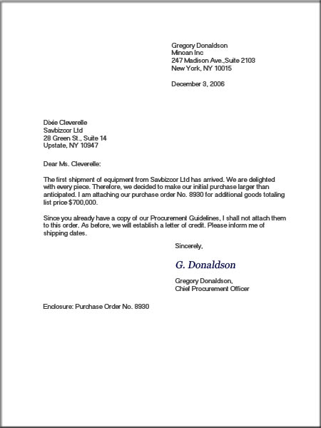

**Letter 3**

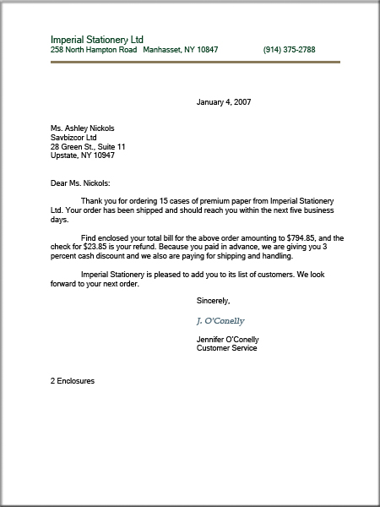

**Ex. 2 Correcting mistakes. There are some mistakes in the layout of the following letter. Find them and write out the letter correctly in the modern block style.**

183 north Street

Island World Holidays

London WM1 3FM

Tel. 016769096

Miss Margaret Smith,

Scottsberget, 26

Goteborge 41805,

Sweden

Your ref.

Our ref.: FH/ts

Dear Sir

Thank you for your letter of the seventeenth of June twenty and sixteen. I have the pleasure in sending you our brochure with details of all our holidays. I look forward to hearing from you.

2016, june17th

Best wishes Fred Henderson

Sales Manager

Fred Henderson

**Ex. 3 The following are the “Golden Rules” of letter-writing. Some of the key words are scrambled. Unscramble them.**

1.Give your letter a **ihdegan** … as it makes easier for the reader to understand your purpose in writing.

2. Always plan your letter **aehda** … .

3. Use short **esesentnc** … .

4. Put each separate idea in separate **sahargppra** … . Number them if it helps the reader to understand better.

5. Avoid long clichés, bad language and abuse.

6. Think about your reader. The reader

- must be able to see exactly what you mean:

- your letters should be **ralce** … ,

- must be given all necessary information:

- your letters should be **ocptemle** … ,

- is probably a busy person with no time to waste:

- your letters should be **cnoices** … ,

- should be respected:

- your letters should be **cueurtsoo** … ,

- should not be distracted by mistakes in grammar, punctuation or spelling:

- your letters should be **tocrerc** … .

**Ex. 4 Join the salutations to the right complimentary closes.**

Dear Sales Manager 1 Best wishes

Gentlemen Peter Peter

Dear Ms Brown 2 Yours faithfully

Dear Sir R. Swindow

To whom it may concern Richard Swindow

Dear Jack 3 Yours sincerely

Dear Mrs Sweetee Samantha Alabama

Dear Messrs Samantha Alabama

**Ex. 5** **Write the following dates in British and American English.**

6/ 12/ 2005 07.11. 2011

Jan. 19th, 2015 today’s date

the third of March, 2016

**Ex. 6 Add the missing salutation or close.**

The Sales Manager Ms S Brown

Alfa Bank Smith and Co.

London 67 Oxford Road

Dear … Bath SW6 8GH

Yours … …

…

Clarks Shoe Company Dear John

81 South Street …

Street DF3 7SW

…

…